Python Programming Challenges

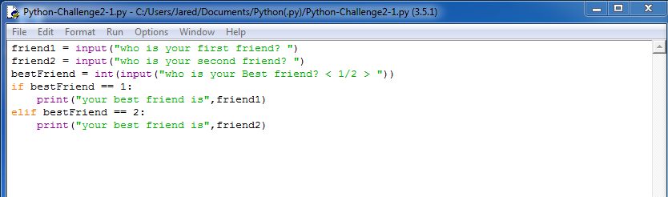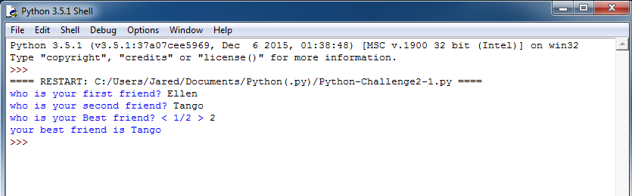**Challenge 2-1 Best Friend:**

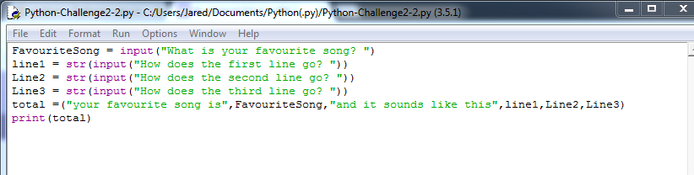**Challenge 2-2 Favourite song:**

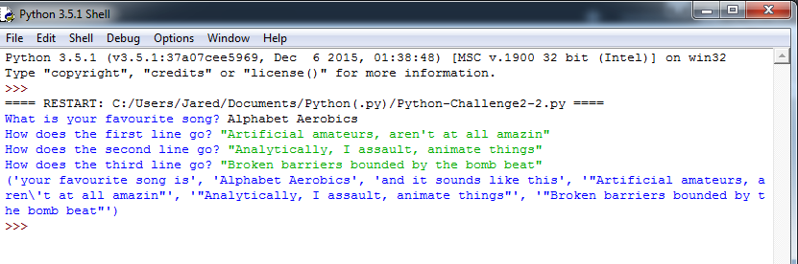

**Challenge 2-3 PiggyBank:**

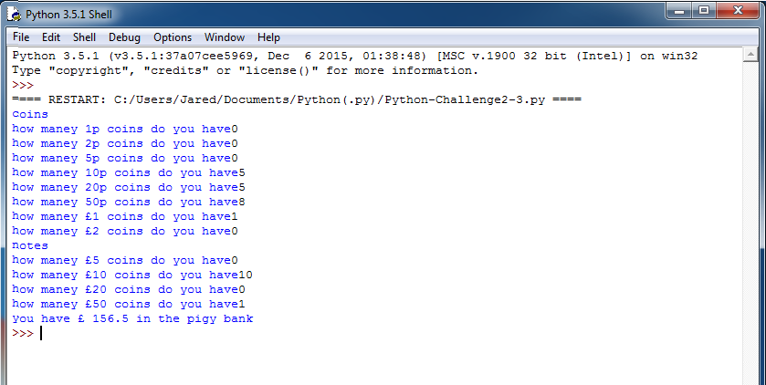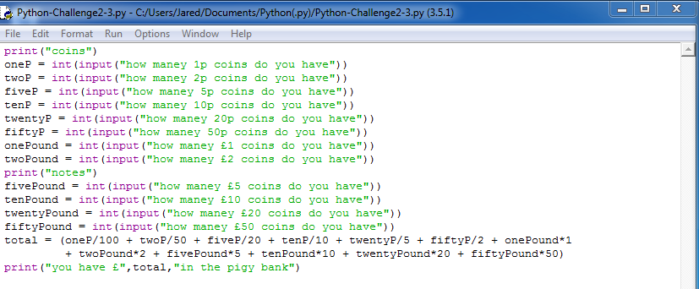

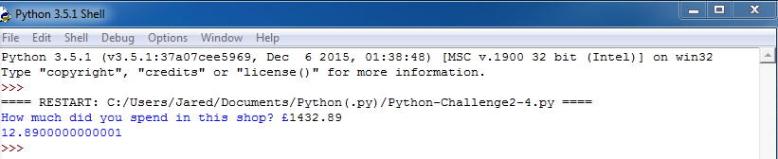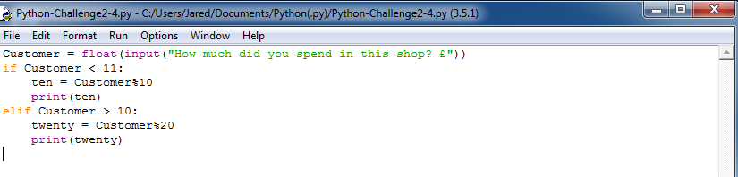**Challenge 2-4 Customer Discount:**

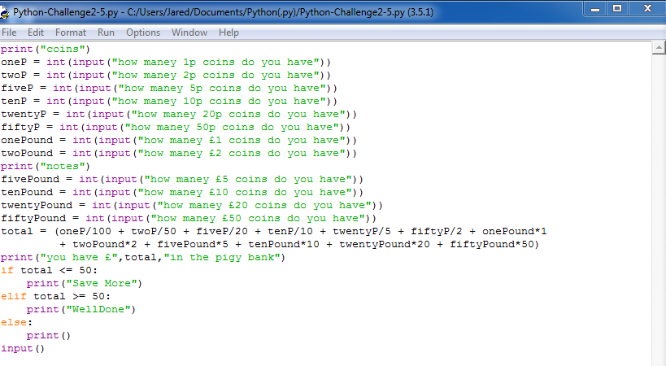**Challenge 2-5 Piggy Bank 2:**

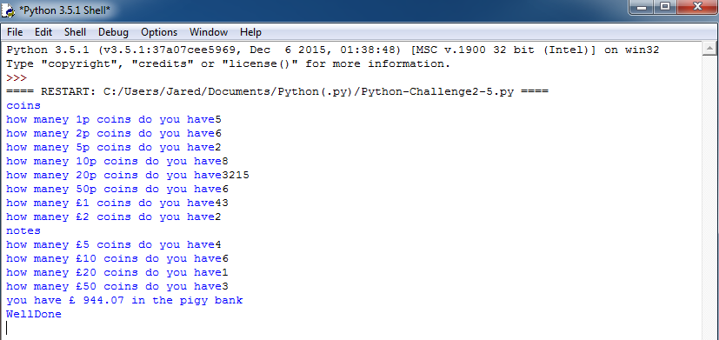

**Challenge 2-6:**

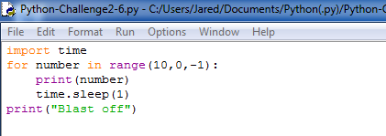

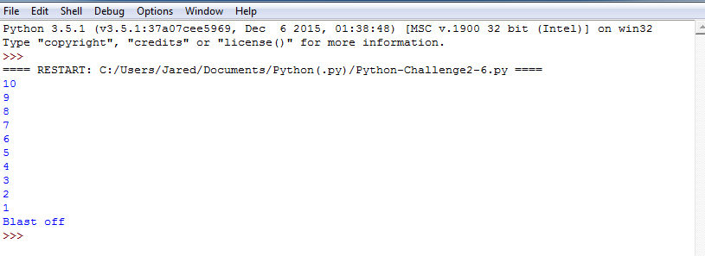

**Challenge 2-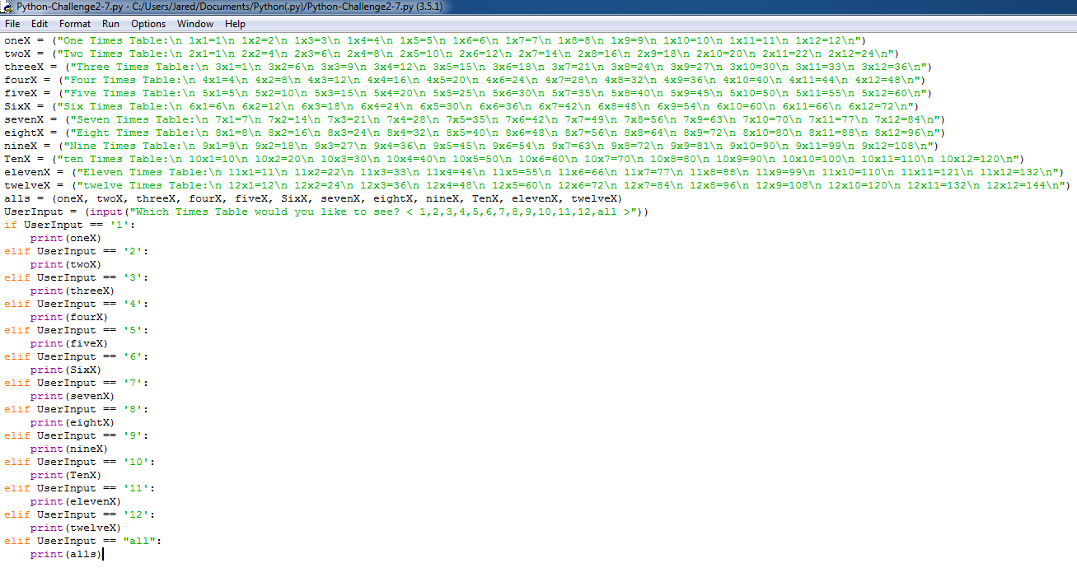7:**

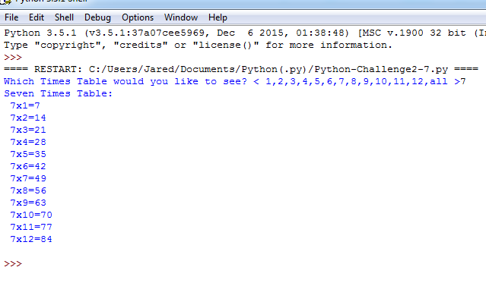

**Challenge 2-8:**